**FXF CAMP FREIGHT**

**Details:**

* **From Dec 1st – Feb 1st**
* **Tickets will have “ FXF Camp CAFÉ” in the notepad**
* **Tickets will include freight number in notes**

**Special Instructions:**

* **Complete codes to be used are:**
  + **FXF CAMP Completed**
  + **FXF CAMP Customer Refused**
    - **Details of refusal must be in notes. i.e. *The customer thought CAFÉ was too cumbersome and had rather stay on the Freight Single Website (SWS).***
    - **Advise customers Freight SWS will be retiring soon**
* **DO NOT TERMINATE: assign to Kyle’s workload 781580**
* **Any tickets failing to follow the process need to be brought to a supervisor’s attention.**

**How to Access ACCOPS**

**Click the “Start” button and search for “Remote Desktop Connection”**

**In the window that pops up, type in “ts.freight.fedex.com” and hit “Connect”**

**Please enter in your login and LDAP password. You want to Log into “ARFW”.**

**Your login will be in the following format: “FXL0000”, with “F” being your first initial, “L” being your last initial, and 0000 being the last 4 numbers of your FedEx Employee ID.**

**Once it connects, you will see a lot of pop up windows indicating “IP ADDRESS NOT FOUND”. This is normal, so just close these windows when they appear. You will also get a prompt about printer selection; feel free to close this.**

**Click “Start”, “Programs”, “Operations”, and “Customer Maintenance”. You will see a popup window indicating “IP ADDRESS NOT FOUND”. This is normal, so just click OK.**

**The rest of the steps can be found in KB 14342, and the pertinent parts have been included below.**

[**http://helpdesk-fedex.custhelp.com/app/answers/detail/a_id/14342/kw/14342**](http://helpdesk-fedex.custhelp.com/app/answers/detail/a_id/14342/kw/14342)

**Please note, our process for logging in to ACCOPS is different than displayed in the KB.**

1. **Click Customer Search**

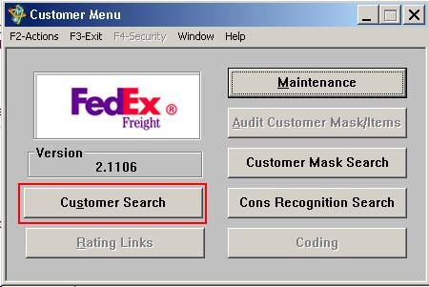

1. 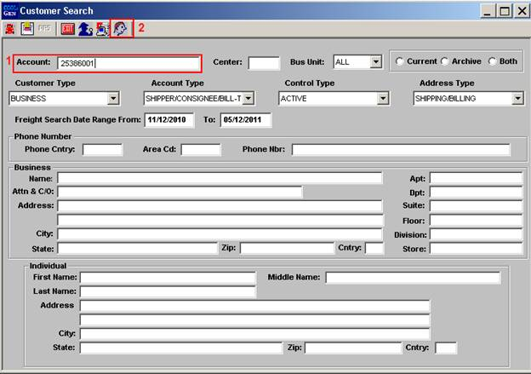**Enter the LTL account number in the “Account” field. Do NOT press “Enter”. Click the small profile of a face icon.**

**If you do not know the account number**

* 1. **Enter the company name in the “Name” field and press “Enter”.**

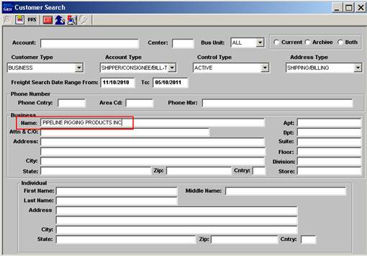

* 1. **If this customer has an LTL account a pop up window with the search results which includes the companies Freight Account number will appear. Return to the Customer Search screen and follow the steps using the Account number.**

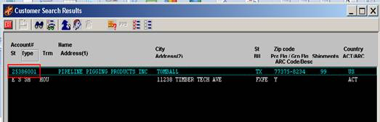

1. **The “Cust Prof” screen will provide information about the account including the Ship from address, Account type, Account status and Cash Only status.**

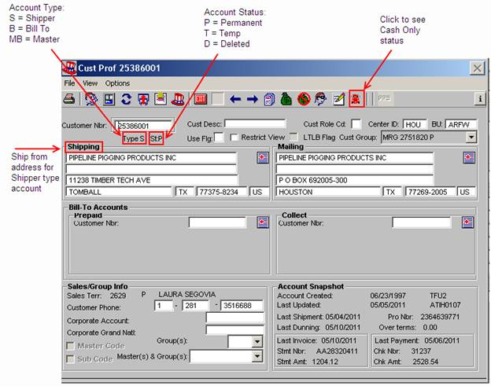

|  |  |
| --- | --- |
| **http://esupport.fedex.custhelp.com/rnt/rnw/img/enduser/fedex/powership_cafe/info.jpg** | **Be advised that CASH ONLY in LTL Freigt is NOT the same as CASH ONLY in Express. Usually it means that the account is new and no shipments have been processed using the account. Call the Freight/LTL helpdesk at 866-756-3590 and advise them of the issue. They can remove the CASH ONLY flag is possible.** |

1. **The Shipping address and the Mailing address found the “Cust Prof” screen must match what is entered into the FSM “Add Freight Account” screen referred to** [**here**](http://helpdesk-fedex.custhelp.com/app/answers/detail/a_id/14342/kw/14342#1)**. The Mailing address in ACCOPS is the Billing Address in FSM.**

